Programm

namespace OPIlab

{

public struct Detail

{

public string code;

public string category;

public int quantity;

public float price;

}

internal static class Program

{

/// <summary>

/// Главная точка входа для приложения.

/// </summary>

[STAThread]

static void Main()

{

Application.EnableVisualStyles();

Application.SetCompatibleTextRenderingDefault(false);

Application.Run(new Form1());

}

}

}

Form 1

namespace OPIlab

{

using System;

using static System.Windows.Forms.AxHost;

using static System.Windows.Forms.VisualStyles.VisualStyleElement;

using static System.Windows.Forms.VisualStyles.VisualStyleElement.TextBox;

public partial class Form1 : Form

{

public int counterMD;

public Detail[] md;

public Detail[] rd;

public void PrintMD(Detail []md, int i)

{

dataGrid.Rows.Add();

dataGrid.Rows[i].Cells[0].Value = i + 1;

dataGrid.Rows[i].Cells[1].Value = md[i].code;

dataGrid.Rows[i].Cells[2].Value = md[i].category;

dataGrid.Rows[i].Cells[3].Value = md[i].quantity;

dataGrid.Rows[i].Cells[4].Value = md[i].price;

dataGrid.Rows[i].Cells[5].Value = md[i].quantity * md[i].price;

}

public Form1()

{

InitializeComponent();

counterMD = 0;

md = new Detail[7];

counterMD = 7;

md[0].code = "25";

md[0].category = "klin";

md[0].quantity = 5;

md[0].price = 10;

md[1].code = "253";

md[1].category = "klin";

md[1].quantity = 50;

md[1].price = 10;

md[2].code = "5";

md[2].category = "dsjlkgh";

md[2].quantity = 35;

md[2].price = 120;

md[3].code = "256";

md[3].category = "likdhjoi";

md[3].quantity = 59;

md[3].price = 10;

md[4].code = "532";

md[4].category = "klin";

md[4].quantity = 15;

md[4].price = 153;

md[5].code = "500";

md[5].category = "wewe";

md[5].quantity = 11;

md[5].price = 15;

md[6].code = "25";

md[6].category = "klin";

md[6].quantity = 30;

md[6].price = 9;

}

private void toolStripMenuItem3_Click(object sender, EventArgs e)

{

Form2 examp = new Form2();

//examp.Show();

examp.Owner = this;

examp.ShowDialog();

if (examp.DialogResult == DialogResult.OK)

{

counterMD++;

Array.Resize(ref md, counterMD);

md[counterMD-1] = examp.d;

ToolStripMenuItem6_Click(sender,e);

}

}

private void toolStripMenuItem4_Click(object sender, EventArgs e)

{

int del = 0; bool flag = false;

Form4 form4 = new Form4();

form4.ShowDialog();

del = form4.del - 1;

dataGrid.Rows.Clear();

if (form4.DialogResult == DialogResult.OK && del != -1 && del < counterMD && counterMD != 0)

{

counterMD--;

for (int i = 0; i < counterMD; i++)

{

if (i == del)

flag = true;

if (flag)

md[i] = md[i + 1];

}

Array.Resize(ref md, counterMD);

for (int i = 0; i < md.Length; i++) PrintMD(md, i);

}

}

private void ToolStripMenuItem6_Click(object sender, EventArgs e)

{

int i,j;

dataGrid.Rows.Clear();

for(i= 0; i < md.Length; i++)

{

PrintMD(md, i);

}

}

private void ToolStripMenuItem7_Click(object sender, EventArgs e)

{

string categ;

int counterCateg=0;

Form3 examp = new Form3();

examp.Owner = this;

examp.ShowDialog();

categ = examp.categ;

dataGrid.Rows.Clear();

for(int i = 0; i < md.Length; i++)

{

if (md[i].category == categ) {

dataGrid.Rows.Add();

dataGrid.Rows[counterCateg].Cells[0].Value = counterCateg + 1;

dataGrid.Rows[counterCateg].Cells[1].Value = md[i].code;

dataGrid.Rows[counterCateg].Cells[2].Value = md[i].category;

dataGrid.Rows[counterCateg].Cells[3].Value = md[i].quantity;

dataGrid.Rows[counterCateg].Cells[4].Value = md[i].price;

dataGrid.Rows[counterCateg].Cells[5].Value = md[i].quantity * md[i].price;

counterCateg++;

}

}

}

private void ToolStripMenuItem8_Click(object sender, EventArgs e)

{

int counterPrice = 0;

float total, maxPrice;

string maxCat = md[0].category; ;

total = maxPrice = 0;

dataGrid.Rows.Clear();

for (int i = 0; i < md.Length; i++)

{

total = 0;

for (int j = 0; j < md.Length; j++)

{

if (md[i].category == md[j].category)

total = total + md[j].quantity * md[j].price;

}

if (maxPrice < total)

{

maxPrice = total;

maxCat = md[i].category;

}

}

for (int i = 0; i < md.Length; i++)

{

total = md[i].quantity * md[i].price;

if (md[i].category == maxCat)

{

dataGrid.Rows.Add();

dataGrid.Rows[counterPrice].Cells[0].Value = counterPrice + 1;

dataGrid.Rows[counterPrice].Cells[1].Value = md[i].code;

dataGrid.Rows[counterPrice].Cells[2].Value = md[i].category;

dataGrid.Rows[counterPrice].Cells[3].Value = md[i].quantity;

dataGrid.Rows[counterPrice].Cells[4].Value = md[i].price;

dataGrid.Rows[counterPrice].Cells[5].Value = md[i].quantity * md[i].price;

counterPrice++;

}

}

}

private void ToolStripMenuItem9_Click(object sender, EventArgs e)

{

//string []codF;

Form5 form5 = new Form5();

form5.Owner = this;

form5.ShowDialog();

}

public bool flaf=false;

private void ToolStripMenuItem10_Click(object sender, EventArgs e)

{

rd=new Detail[md.Length];

for(int i=0;i<md.Length;i++)

rd[i] = md[i];

Detail temp;

temp = new Detail();

dataGrid.Rows.Clear();

if (flaf)

{

for (int i = 0; i < md.Length - 1; i++)

{

for (int j = 0; j < md.Length - i - 1; j++)

{

if (rd[j].price < rd[j + 1].price)

{

temp = rd[j];

rd[j] = rd[j + 1];

rd[j + 1] = temp;

}

}

}

for (int i = 0; i < md.Length; i++) PrintMD(rd, i);

flaf = false;

}

else {

for (int i = 0; i < md.Length - 1; i++)

{

for (int j = 0; j < md.Length - i - 1; j++)

{

if (rd[j].price > rd[j + 1].price)

{

temp = rd[j];

rd[j] = rd[j + 1];

rd[j + 1] = temp;

}

}

}

for (int i = 0; i < md.Length; i++) PrintMD(rd, i);

flaf = true;

}

}

}

}

Form 2

namespace OPIlab

{

public partial class Form2 : Form

{

public Detail d;

public Form2()

{

InitializeComponent();

}

private Detail getDetail()

{ return d; }

private void button2_Click(object sender, EventArgs e)

{

Close();

}

private void button1_Click(object sender, EventArgs e)

{

if (textCode.Text == string.Empty)

{

MessageBox.Show("Недопустимые значения параметров.", "Ошибка");

return;

}

d.code = textCode.Text;

if (textCat.Text == string.Empty)

{

MessageBox.Show("Недопустимые значения параметров.", "Ошибка");

return;

}

d.category=textCat.Text;

if (textQ.Text==string.Empty)

d.quantity = 0;

else d.quantity = int.Parse(textQ.Text);

if (textP.Text == string.Empty)

d.price = 0;

else d.price = float.Parse(textP.Text);

Close();

}

}

}

Form 3

namespace OPIlab

{

public partial class Form3 : Form

{

public string categ;

public Form3()

{

InitializeComponent();

}

private void button2_Click(object sender, EventArgs e)

{

Close();

}

private void button1_Click(object sender, EventArgs e)

{

if(textBox1.Text==string.Empty)

{

MessageBox.Show("Недопустимые значения параметров.", "Ошибка");

return;

}

categ = textBox1.Text;

}

}

}

Form 4

namespace OPIlab

{

public partial class Form4 : Form

{

public int del;

public Form4()

{

InitializeComponent();

}

private void button2_Click(object sender, EventArgs e)

{

Close();

}

private void button1_Click(object sender, EventArgs e)

{

if (textBox1.Text == string.Empty)

{

MessageBox.Show("Недопустимые значения параметров.", "Ошибка");

return;

}

//Text = textBox1.Text;

del = int.Parse(textBox1.Text);

Close();

}

}

}

Form 5

namespace OPIlab

{

public partial class Form5 : Form

{

public int[] totalAmount = new int[] { };

public float[] totalPrice = new float[] { };

public Detail[] md;

public void print(int i)

{

dataGridView.Rows.Add();

dataGridView.Rows[i].Cells[0].Value = i + 1;

dataGridView.Rows[i].Cells[1].Value = codeFind[i];

dataGridView.Rows[i].Cells[2].Value = totalAmount[i];

dataGridView.Rows[i].Cells[3].Value = totalPrice[i];

}

public int countC;

public string[] codeFind;

public Form5()

{

InitializeComponent();

countC = 0;

codeFind = new string[] { };

}

private void button2_Click(object sender, EventArgs e)

{

Close();

}

private void button1_Click(object sender, EventArgs e)

{

Form1 examp = new Form1();

//examp.Show();

examp.Owner = this;

md = new Detail[examp.md.Length];

md = examp.md;

if (textBox1.Text == string.Empty)

{

MessageBox.Show("Недопустимые значения параметров.", "Ошибка");

return;

}

else

{

countC++;

Array.Resize(ref codeFind, countC);

codeFind[countC-1] = textBox1.Text;

}

dataGridView.Rows.Clear();

Array.Resize(ref totalAmount, codeFind.Length);

Array.Resize(ref totalPrice, codeFind.Length);

for (int i = 0; i < codeFind.Length; i++)

{

totalAmount[i] = 0;

totalPrice[i] = 0;

for (int j = 0; j < md.Length; j++)

{

if (codeFind[i] == md[j].code)

{

totalAmount[i] = totalAmount[i] + md[j].quantity;

totalPrice[i] = totalPrice[i] + md[j].price*md[j].quantity;

}

}

}

for (int i = 0; i < codeFind.Length; i++)

{

print(i);

}

}

private void button3_Click(object sender, EventArgs e)

{

int countF = 0;

bool flag = false;

string codeDel = textBox1.Text;

if (textBox1.Text == string.Empty)

{

MessageBox.Show("Недопустимые значения параметров.", "Ошибка");

return;

}

int i = 0;

while (i < codeFind.Length)

{

if (codeFind[i] == codeDel)

{

countF++;

countC--;

for (int j = i; j < codeFind.Length - 1; j++)

codeFind[j] = codeFind[j + 1];

Array.Resize(ref codeFind, codeFind.Length - 1);

}

else i++;

}

dataGridView.Rows.Clear();

for (i = 0; i < codeFind.Length; i++)

print(i);

}

}

}

Главный экран

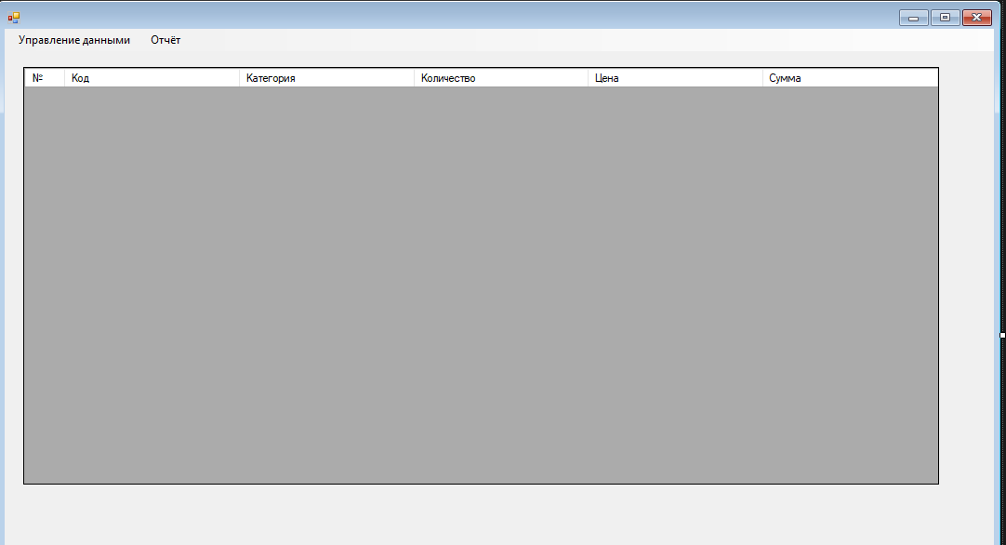

Добавление детали

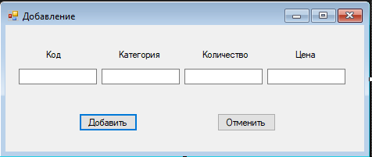

Удаление детали

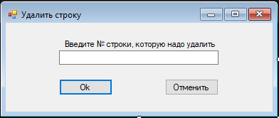

Фильтр по категории

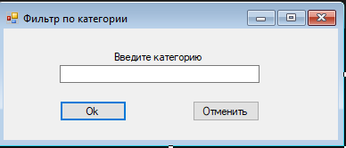

Поиск суммарного количества по каждому из кодов деталей

